# Maps and Sets Exercise

Quick Question #1

What does the following code return?

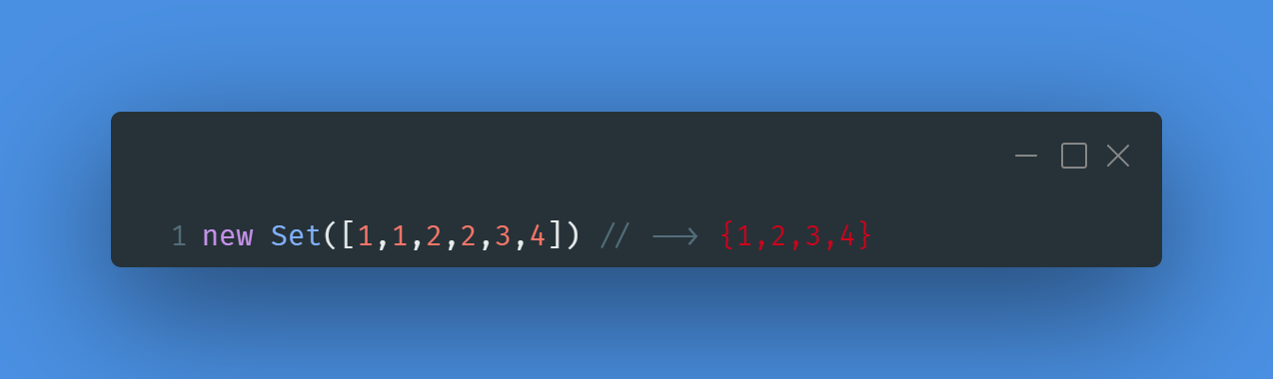

Quick Question #2

What does the following code return?

Quick Question #3

What does the Map **m** look like after running the following code?

